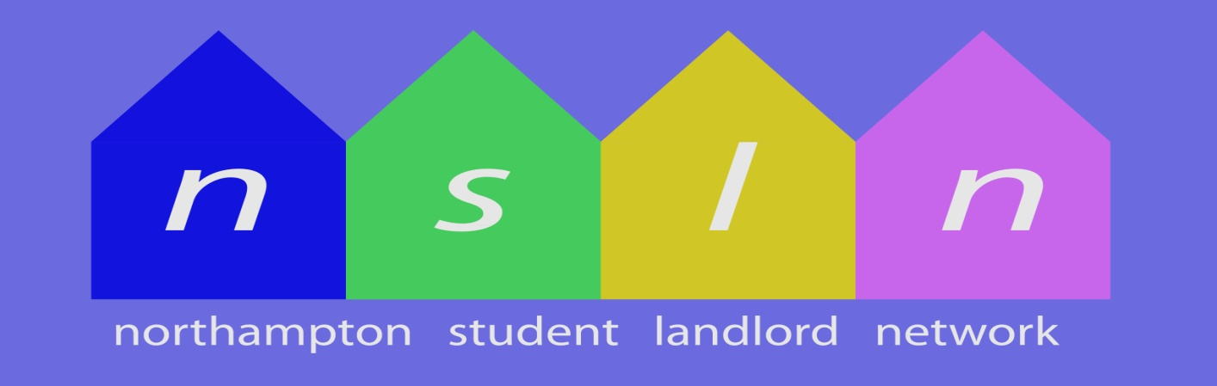
Key Objectives:-
- Information & Guidance
To provide specific & timely information & guidance to both landlords & students
- Communication Network
To facilitate an effective communication network for landlords letting to students
- Positive Voice
To provide a representative and positive voice for our members

Key Activities:-
- Meetings
The organisation and delivery of meetings for landlords, the participation in quarterly meetings with NBC, UoN, SU & DASH, and internal committee meetings
- Lobbying
Liaising with and lobbying of the University and Borough Council and other organisations on issues of concern for members
- Facebook Group
Providing information & feedback, and encouraging discussion and the sharing of experiences and ideas for the mutual benefit of group members
- University Events
Participation in various University housing events to provide information, advice and guidance to students

Contact Us:-
Landlords:-
- Join the “Northampton Student Landlord Network” Facebook Group
Students:-
- Email: NptonSLN@gmail.com

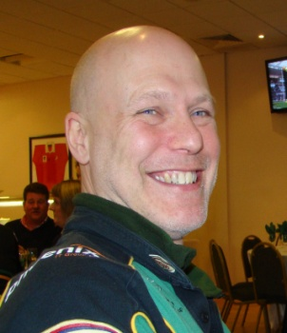 | 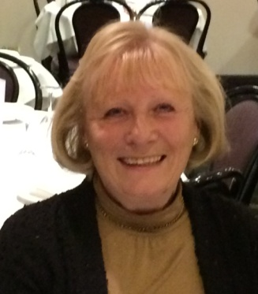
Rich Dawson  (NSLN Chairman) | Susan Dowding | Jenny Cross | Richard Lee

